ASSIGNMENT Chapter 7

Statistical Methods

Questions
M & S 313-315
(LARGE SAMPLES)
7.10, 7.12, 7.14, 7.20, 7.22
M & S 323-325
(SMALL SAMPLES)
7.32, 7.35, 7.40
M & S 332-333
(PROPORTIONS)
7.50, 7.51, 7.53
M & S 338-339
(SAMPLE SIZE)
7.66, 7.71, 7.78

7.10 (3 points) A random sample of 90 observations produced a mean $\bar{x}$= 25.9 and a standard deviation of s= 2.7.

- Find a 95% confidence interval for μ
- Find a 90% confidence interval for μ.
- Find a 99% confidence interval for μ.

Answers: 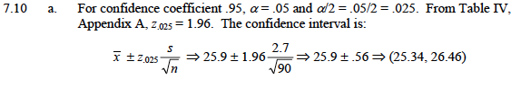 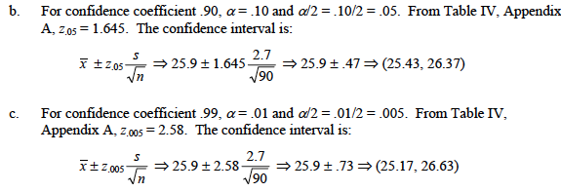

7.12 (3 points) The mean and standard deviation of a random sample of n measurements are equal to 33.9 and 3.3, respectively.

- Find a 95% confidence interval for μ if n= 100.
- Find a 95% confidence interval for μ if n= 400.
- Find the widths of the confidence intervals you calculated in parts a and b. What is the effect on the width of a confidence interval of quadrupling the sample size while holding the confidence coefficient fixed?

7.14 (4 points) Personal networks of older adults. In sociology, a personal network is defined as the people with whom you make frequent contact. The Living Arrangements and Social Networks of Older Adults (LSN) research program used a stratified random sample of men and women born between 1908 and 1937 to gauge the size of the personal network of older adults. Each adult in the sample was asked to “please name the people (e.g., in your neighborhood) you have frequent contact with and who are also important to you.” Based on the number of people named, the personal network size for each adult was determined. The responses of 2,819 adults in the LSN sample yielded the following statistics on network size: $\bar{x}$ = 14.6; s = 98 Sociological Methods and Research, August 2001.)

- Give a point estimate for the mean personal network size of all older adults.
- Form a 95% confidence interval for the mean personal network size of all older adults.
- Give a practical interpretation of the interval you found in part b.
- Give the conditions required for the interval in part b to be valid.

Answers for 7.12 and 7.14:
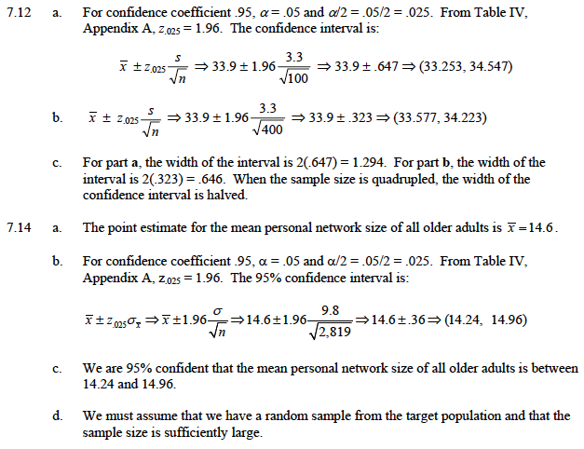

7.20 (2 points) Velocity of light from galaxies. Refer toe the Astronomical Journal (July 1995) study of the velocity of light emitted from a galaxy in the universe, presented in Exercise 2.100(p.74). A sample of 103 galaxies located in the galaxy cluster A2142 had a mean velocity of $\bar{x}$ = 27,117 kilometers per second (km/s) and a standard deviation of s = 1,280 km/s. Suppose your goal is to make an inference about the population mean light velocity of galaxies in cluster A2142.

- In part b of Exercise 2.100, you constructed an interval that captured approximately 95% of the galaxy velocities in the cluster. Explain why that interval is inappropriate for the inference you are asked to make here.
- Construct a 95% confidence interval for the mean light velocity emitted
form all galaxies in cluster A2142. Interpret the result.

Answers:
b. Answer in 7.22 (mistake)

7.22 (2 points) Attention time given to twins. Psychologists have found that twins, in their early years, tend to have lower IQs and pick up language more slowly than nontwins. (Wisconsin Twin Research Newsletter, Winter 2004). The slower intellectual growth of most twins may be caused by benign parental neglect. Suppose it is desired to estimate the mean attention time given to twins per week by their parents. A sample of 50 sets a 2.5-year-old twin boys is taken, and at the end of 1 week, the attention time given to each pair is recorded. The data (in hours) are listed in the following table:

20.7 16.7 22.5 1.1 2.9
23.5 6.4 1.3 39.6 35.6
10.9 7.1 46.0 23.4 29.4
44.1 13.8 24.3 9.3 3.4
15.7 46.6 10.6 6.7 5.4
14.0 20.7 48.2 7.7 22.2
20.3 34.0 44.5 23.8 20.0
43.1 14.3 21.9 17.5 9.6
36.4 0.8 1.1 19.3 14.6
32.5 19.1 36.9 27.9 14.0

Find a 90% confidence interval for the mean attention time given to all twin boys by their parents. Interpret the confidence interval.

Answers: 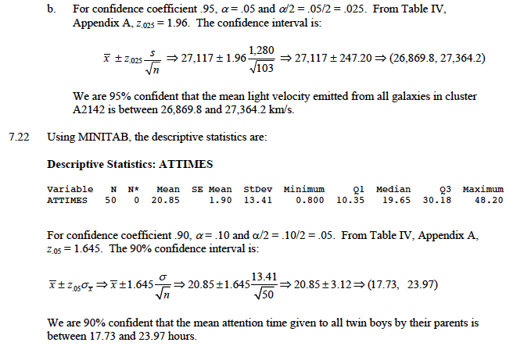

7.32 (3 points) The following sample of 16 measurements was selected form a population that is approximately normally distributed:

91 80 99 110 95 106 78 121 106 100 97 82 100 83 115 104

- Construct an 80% confidence interval for the population mean.
- Construct a 95% confidence interval for the population mean and compare the width of this interval with that of part a.
- Carefully interpret each of the confidence intervals, and explain why the 80% confidence interval is narrower.

Answers: 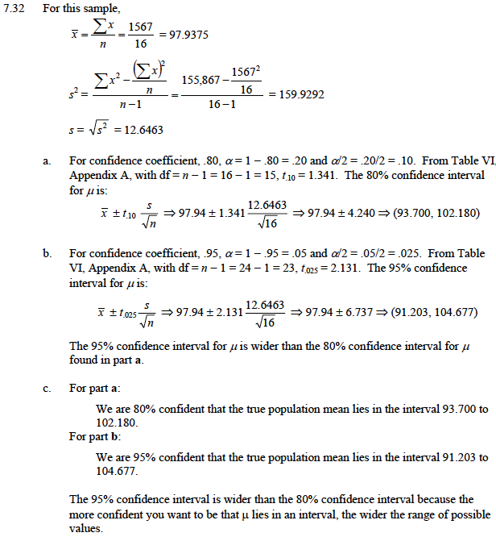

7.35 (5 points) Radioactive Lichen. Refer to the Lichen Radionuclide Baseline Research project at the University of Alaska, presented in Exercise 2.34 (p.47). Recall that the researchers collected 9 lichen specimens and measured the amount (in microcuries per milliliter) of the radioactive element cesum-137 for each. (The natural logarithms of the data values are saved in the Lichen file.) A MINITAB printout with summary statistics for the actual data is shown above.

- Give a point estimate for the mean amount of cesium in lichen specimens collected in Alaska.
- Give the t-value used in a small-sample 95% confidence interval for the true mean amount of cesium in Alaskan lichen specimens.
- Use the result you obtained in part b and the values of $\bar{x}$ and s shown on the MINITAB printout to form a 95% confidence interval for the true mean amount of cesium in Alaskan lichen specimens.

Answers: (a) .009

(b) 2.306

(c) .009 +/- .0037

7.40 (4 points) Minimizing tractor skidding distance. In planning for a new forest road to be used for tree harvesting, planners must select the location that will minimize tractor skidding distance. In the Journal of Forest Engineering (July 1999), researchers wanted to estimate the true mean skidding distance along new road in a European forest. The skidding distance (in meters) were measured at 20 randomly selected road sites. These values are given in the accompanying table.

- Estimate, with a 95% confidence interval, the true mean skidding distance of the road.
- Giave a practical interpretation of the interval you found in part a.
- What conditions are required for the inference you made in part b to be valid? Are these conditions reasonably satisfied?
- A logger working on the road claims that the mean skidding distance is at least 425 meters. Do you agree?

Skidding
488 350 457 199 285 409 435 574 439 546 385 295 184 261 273 400 311 312 141 425
Answers: 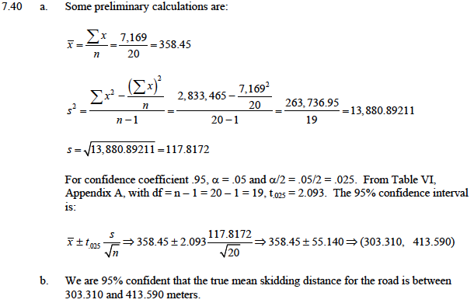

7.50 (2 points) A random sample of 50 consumers taste-tested a new snack food. Their responses were coded (0; don not like; 1; like; 2; indifferent) and recorded as follows

Snack
1 0 0 1 2 0 1 1 0 0 0 1 0 2 0 2 2 0 0 1 1 0 0 0 0 0 1 0 2 0 0 0 1 0 0 1 0 0 1 0 1 0 2 0 0 1 1 0 0 0 1

- Use an 80% confidence interval to estimate the proportion of consumers who like the snack food.
- Provide a statistical interpretation for the confidence interval you constructed in part a.

Answers: 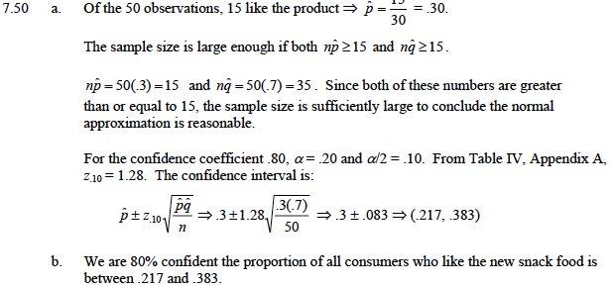

7.51 (3 points) National Firearms Survey. Refer to the Harvard School of Public Health survey to determine the size and the composition of privately held firearm stock in the United States, presented in Exercise 2.6 (p. 34). Recall that, in a representative household telephone survey of 2,770 adults, 26% reported that they own at least one gun. (Injury Prevention, Jan. 2007.) The researchers want to estimate the true percentage of adults in the United States that own at least one gun.

- Identify the population of interest to the researchers.
- Identify the parameter of interest to the researchers.
- Compute an estimate of the population parameter.

Answers: (a) set of all gun ownership status (yes/no) values for all U.S. adults

(b) true percentage of all adults who own a gun

(c) .26

(d) .26 +/- .02

7.53 (2 points) What we do when we are sick at home. USA Today (Feb. 15, 2007) reported on the results of an opinion poll in which adults were asked what one thing they are most likely to do when they are home sick with a cold or the flu. In the survey, 63% said that they are most likely to sleep and 18% said that they would watch television. Although the sample size was not reported, typically opinion polls include approximately 1,000 randomly selected respondents.

- Assuming a sample size of 1,000 for this poll, construct a 95% confidence interval for the true percentage of all adults who would choose to sleep when they are at home sick.
- If the true percentage of adults who would choose to sleep when they are at home sick is 70%, would you be surprised? Explain.

Answers: (a) .63 +/- .03
(b) yes

7.66 (2 points) If nothing is known about $p$, .5 can be substituted for $p$ in the sample-size formula for a population proportion. But when this is done, the resulting sample-size formula yield a sample size larger than is needed to construct a confidence interval for $p$ with a specified bound and a specified confidence level?
Answers:

7.71 (2 points) Suppose you wish to estimate the mean of a normal population with a 95% confidence interval and you know from prior information that $s^{2}$$»$ 

- To see the effect of the sample size on the width of the confidence interval, calculate the width of the confidence interval for $n$ = 16,25,49,100, and 400.

Answers:
n = 16; W = .98
n = 25; W = .748
n = 49; W = .56
n = 100; W = .392
n = 400; W = .196

7.78 (2 points) Asthma drug study. The chemical benzalkonium chloride (BAC) is an antibacterial agent that is added to some asthma medications to prevent contamination. Researchers at the University of Florida College of Pharmacy have discovered that adding BAC to asthma drugs can cause airway constriction in patients. In a sample of 18 asthmatic patients, each of whom received a heavy dose of BAC, 10 experienced a significant drop in breathing capacity (Journal of Allergy and Clinical Immunology, January 2001.) Based on this information, a 95% confidence interval for the true percentage of asthmatic patients who experience breathing difficulties after taking BAC is (.326, .785).

- Why might the confidence interval lead to an erroneous interference?
- How many asthma patients must be included in the study in order to estimate the true percentage who experience a significant drop in breathing capacity within 4% with a 95% confidence interval?

Answers:
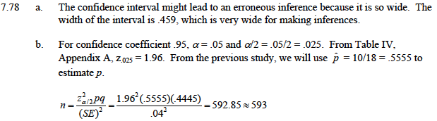

Total points: 39

