ASSIGNMENT 3.1

Statistical Methods

Probability
M&S 124-125,177, 134-137

NAME:

3.9 (3 points) An experiment result in one of the following sample points: E₁, E₂, E₃, E4 and E_{5.}
a. Find P (E₃) if P (E₁) = .1, P (E2) = .2, P (E₄) = .1, and P (E5) = .1

b. Find P (E₃) if P (E₁) = P (E₃), P (E2) = .1, P (E₄) = .2 and P (E₅) = .1

c. Find P (E₃) if P (E₁) = P (E₂) = P (E₄) = P (E₅) = .1

ANSWERS

a. .5

b. .3

c. .6

3.15 (5 points) Two marbles are drawn at random and without replacement from a box containing two blue marbled and three red marbles.

a. List the sample points.

b. Assign probabilities to the sample points.

c. Determine the probability of observing each of the following events:
A: {Two blue marbles are drawn.}

B: {A red and a blue marble are drawn.}

C. {Two red marbles are drawn.}

ANSWERS

a. (R1R2), (R1R3), (R2R3), (R1B1), (R1B2), (R2B1), (R2B2), (R3B1),
(R3B2), (B1B2)

b. 1/10 for each sample point

c. P(A) = 1/10, P(B) = 6/10, P(C) = 3/10

3.19 (2 points) USDA chicken inspection. The United States Department of Agriculture (USDA) reports that, under its standard inspection system, one in every 100 slaughtered chickens passes inspection for fecal contamination. (Tampa Tribune Mar.31, 2000.)
a. If a slaughtered chicken is selected at random, what is the probability that it
passes inspection for fecal contamination?

b. The probability of part a was based on a USDA study which found that 306 of
32,075 chicken carcasses passed inspection for fecal contamination. Do you agree
with the USDA’s statement about the likelihood of a slaughtered chicken passing inspection for fecal contamination?

ANSWERS

a. .01

b. yes

3.24 (4 points) Sex composition patterns of children in families. In having children, is there a genetic factor that causes some families to favor one sex over the other? That is, does having boys or girls “ run in the family”? This was the question of interest in Chance (Fall 2001). Using data collected on children’s sex for over 4,000 American families that had at least two children, the researchers complied the accompanying table. An American family with at least two children is selected, and the sex composition of the first two children is observed.

a. List the sample points for this experiment.

Sex Composition of First Two Children Frequency
Boy-Boy 1,085
Boy-Girl 1,086
Girl-Boy 1,111
Girl-Girl 926
TOTAL 4.208
Source: Rodgers, J. L., and Doughty, D. “Does having boys or girls run in the family?” Chance, Vol. 14, No.4, Fall 2001, Table 3.

b. If having boy is no more likely than having a girl and vice versa, assign a probability to each sample point.

c. Use the information in the table to estimate the sample point probabilities. Do these estimates agree (to a reasonable degree of approximation) with the probabilities you found in part b?

d. Make an inference about whether having boys or girls “runs in the family.”

ANSWERS

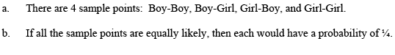

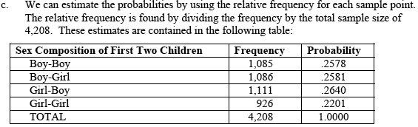

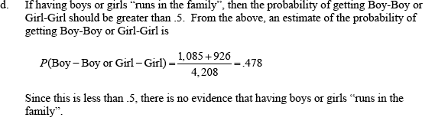

3.181 (2 points) Odd Man Out. Three people play a game called “Odd Man Out.” In this game, each player flips a fair coin until the outcome (heads or tails) for one of the players is not the same as that for the other two players. This player is then “the odd man out” and loses the game. Find the probability that the game ends (i.e., either exactly one of the coins will fall heads or exactly one of the coins will fall tails) after only one toss by each player. Suppose one of the players, hoping to reduce his chances of being the odd man out, uses a two-headed coin. Will this ploy be successful? Solve by listing the sample points in the sample space.

ANSWER

Probabilities are the same.

3.44 (7 points ) Consider the following Venn diagram, where
P (E₁) = .10, P (E₂) = .05, P (E₃) = P (E₄) = .2,
P (E₅) = .06, P (E₆) = .3, P (E₇) = .06, and
P (E₈) = .03

• E₁

•A

•E₇

•E₃
•E₂
•B

•E₅ •
E₆ E₆ B

•E₄

• E₈

S
Find the following probabilities:
a. P (A^{c})

b. P (B^{c})

c. P (A^{c} ∪ B)

d. P (A∪ B)

e. P (A ∩ B)

f. P (A^{c} ∪ B^{c})

g. Are event A and B mutually exclusive? Why?

ANSWERS

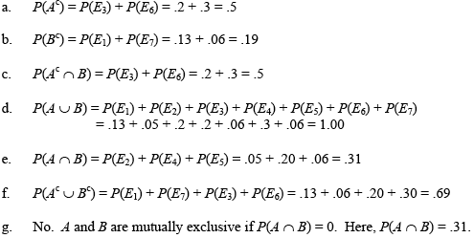

3.45 (8 points) The outcomes of two variables are (Low, Medium, High) and (On, Off), respectively. An experiment is conducted in which the outcomes of each of the two variables are observed. The probabilities associated with each of the six possible outcome pairs are given in the following table:

Low Medium High
On .50 .10 .05
Off .25 .07 .03

Consider the following events:
A: {On}
B: {Medium or On}
C: {Off and Low}
D: {High}
a. Find P (A).

b. Find P (B).

c. Find P (C).

d. Find P (D).

e. Find P (A^{c}).

f. Find P (A ∪ B)
g. Find P (A ∩ B).

h. Consider each possible pair of events taken from the events A, B, C, and D. List
the pairs of event that are mutually exclusive. Justify your choices.

ANSWERS

a. .65

b. .72

c. .25

d. .08

e. .35

f. .72

g. .65

h. A and C,B and C, C and D

3.50 (4 points) Binge alcohol drinking. A study of binge alcohol drinking by college students was published in the American Journal of Public Health (July 1995). Suppose an experiment consists of randomly selecting one of the undergraduate students who participated in the study. Consider the following events:
A: {The student is a binge drinker.}
B: {The student is a male.}
C: {The student lives in a coed dorm.}
Describe each of the following events in terms of unions, intersections, and complements (A ∪ B, A ∩ B, A^{c}, etc.):
a. The student is male and a binge drinker.

b. The student is not a binge drinker

c. The student is male or lives in a coed dorm.

d. The student is female and not a binge drinker.

ANSWERS

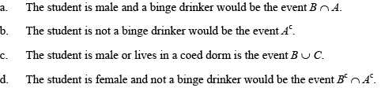

3.56 (7 points) Gang research study. The National Gang Crime Research Center (NGCRC) has developed a six-level gang classification system for both adults and juveniles. The NGCRC collected data on approximately 7,500 confined offenders and assigned each a score, using the gang classification system. (Journal of Gang Research, Winter1997.) One of several other variables measured by the NGCRC was whether or not the offender ever carried a homemade weapon (e.g., a knife) while in custody. The table on p. 138 gives the number of confined offenders in each of the gang score and homemade weapon categories. Assume one of the confined offenders is randomly selected.
a. Find the probability that the offender has a gang score of 5.

b. Find the probability that the offender has carried a homemade weapon.

c. Find the probability that the offender has a gang score below 3.

d. Find the probability that the offender has a gang score of 5 and has carried a
homemade weapon.

e. Find the probability that the offender has a gang score of 0 or has never carried a
homemade weapon.

f. Are the events described in part a and b mutually exclusive? Explain.

g. Are the events described in parts a and c mutually exclusive? Explain

ANSWERS

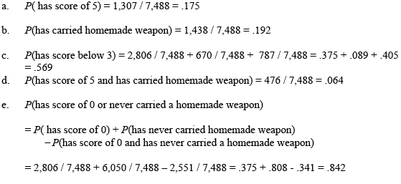

3.57 (1 point) Galileo’s passe-dix game. Passe-dix is a game of chance played with three fair dice. Players bet whether the sum of the faces shown in the dice will be above or below 10. During the late 16th century, the astronomer and mathematician Galileo Galilei was asked by the Grand Duke of Tuscany to explain why “the chance of throwing a total of 9 with three fair dice was less than that of throwing a total of 10.” (Interstat, Jan.2004.) The Grand Duke believed that the chance should be the same, since “there are an equal number of partitions of the numbers 9 and 10.” Find the flaw in the Grand Duke’s reasoning and answer the question posed to Galileo.

ANSWER

P(9) = 25/216 is less than P(10) = 27/216

Total Points: 43

