PART I I

Descriptive Statistics

M&S 77-78

2.106 Compute the z-score corresponding to each of the following values of x;

a. x = 40, s = 5, ‾x = 30

b. x = 90, µ = 89, σ = 2

c. μ = 50, σ = 5, x = 50

d. s = 4, x = 20, ‾x = 30

e In parts a-d, state whether the z-score locates x within a sample or within a
population.

f. In parts a-d, state whether each value of x lies above or below the mean and by how
many standard deviation.

Solution

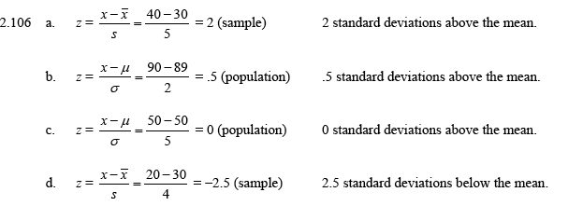

2.110 Math scores of eighth graders. According to the National Center for
Education Statistics (2005), scores on a mathematics assessment test for
United states eighth graders have a mean of 279, a 25th percentile of 225, a
75th percentile of 304, and 90th percentile 324. Interpret each of these
numerical description measures.

Solution

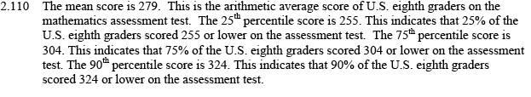

2.116 Blue verses red exam study. In a study of how external clues influence
performance, psychology professors at the University of Alberta and Pennsylvania
State University gave two different forms of midterm examination to a large group
of introductory psychology students. The questions on the exam were identical and
in the same order, but on e was printed on blue paper and the other on red paper.
(teaching Psychology, May 1998) Grading only the difficult questions on the exam,
the researchers found that scores on the blue exam had a distribution with a mean
of 53% and a standard deviation of 15%, while scores on red exam had a
distribution with a mean of 39% and a standard deviation of 12%,( Assume that
both distributions are approximately mound shaped and symmetric.)

a. Give an interpretation of the standard deviation for the students for the students
who took the blues exam.

b. Give an interpretation of the standard deviation for the students for the students
who took the red exam.

c. Suppose a student is selected at random from the group of students who
participated in the study and the student’s scores on the difficult questions is 20%.
Which exam form is the students more likely to have taken, the blue or the red
exam? Explain.

Solution

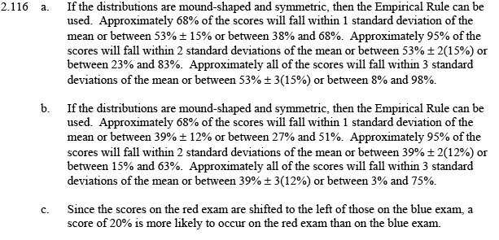

2.117 GPAs of students. At one university, the students are given z-scores at the end of
each semester, rather than the traditional GPAs. The mean and standard deviation
of all students’ cumulative GPAs, on which the z-scores are based, are 2.7 and 5
respectively.
a. Translate each of the following z-scores to corresponding GPA scores z= 2.0, z =
-1.0, z = .5, z = -2.5.
b. Students with z-scores below -1.6 are put on probation. What is the
corresponding probationary GPA?
c. The president of the university wishes to graduate the top 16% of the students
with cum laude honors and the top 2.5% with summa cum honors. Where
(approximately) should the limits be set in trms of z-scores? In terms of GPAs?
What assumption, if any, did you make about the distribution of the GPAs at the
university.

Solution

a. z = 2.0: 3.7; z = -1.0: 2.2; z = .5: 2.95; z = -2.5: 1.45

b. 1.9

c. z = 1.0 and 2.0; GPA = 3.2 and 3.7; mound-shaped, symmetric

2.124 Suppose a data set consisting of exam scores has a lower quartile QL = 60, a median M = 75, and an upper quartile QU = 85. The scores on the exam range from 18 to 100. Without having the actual scores available to you, construct as much of the box pot as possible.

Solution

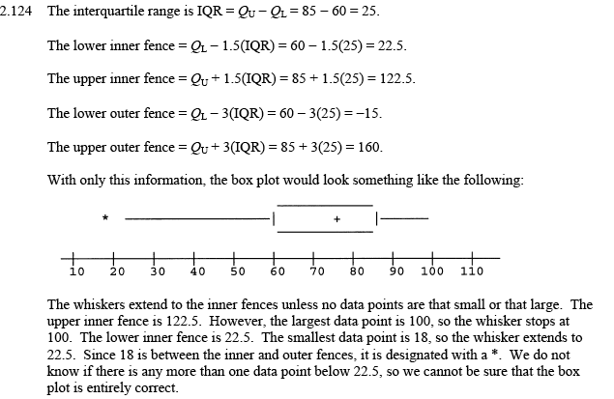

2.126 Consider the following two sample data sets:

LM2_126
---------------------------------------------------------------------------------------------------
Sample A Sample B
---------------------------------------------------------------------------------------------------
121 171 158 171 152 170
173 184 163 168 169 171
157 85 145 190 183 185
165 172 196 140 173 206
170 159 172 172 174 169
161 187 100 199 151 180
142 166 171 167 170 188
---------------------------------------------------------------------------------------------------

a. Construct a box plot for each data set.

b. Identify any outliers that may exist in the two data sets.

Solution

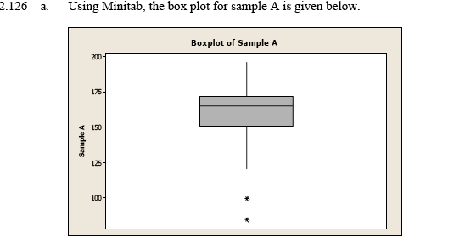

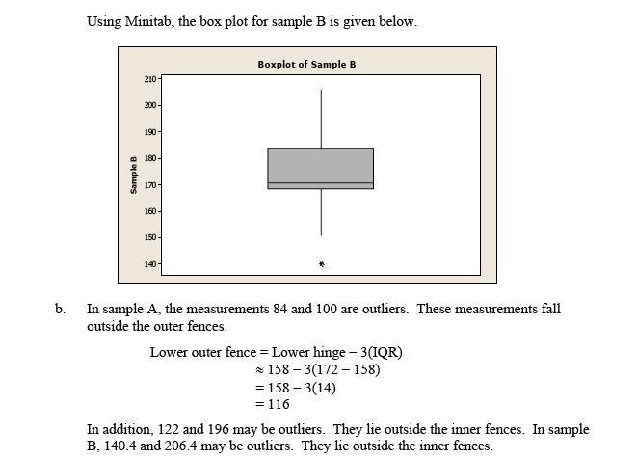

2.129 Research on brain specimens. Refer to the Brain and language data on
postmortem intervals (PMIs) of 22 human brain specimens, presented in Exercise
2.37 (p.48). The mean and standard deviation of the PMI values are 7.3 and 3.18,
respectively.

a. Find the z-scores for the PMI value of 3.3

b. Is the PMI value of 3.3 considered an outlier? Explain.

Solution

a. -1.26

b. No

2.133 Sanitation inspection of cruise ships. Refer to the data on sanitation levels of
cruise ships, presented in Exercise 2.93 (p.73).

a. Use the box plot method to detect any outliers in the data.

b. Use the z-score method to detect any outliers in the data

c. Do the two method s agree? If not, explain why.

Solution

a. 62, 72, 78, and 84

b. 62, 72, and 78

Review

2.164. The data sets in parts a-c have been invented to demonstrate that the lower bounds
given by Chebyshev’s rule are appropriate. Notice that the data are contrived and
would not be encountered in a real-life problem.

a. consider a data set that contains ten 0s two 1s and ten 2s. Calculate ‾x, s², and s.
What percentage of the measurement are in the interval ‾x ± s? compare this
result with that obtained from chebyshev’s rule.

b. Consider a data set that contains five 0s, thirty-two 1s, and five 2s. calculate ‾x ,
s², and s. What percentage of the measurements are in the interval ‾x ± 2s?
Compare this result with that obtained from chebyshev’s rule

c. Consider a data set that contains three 0s, fifty 1s, and three 2s. Calculate ‾x, s²,
and s. What percentage of the measurements are in the interval ‾x ± 3s? Compare
this result with that obtain from Chebyshev’s rule.

d. Draw a histogram for each of the data sets in parts a, b, and c. what do you
conclude from these graphs and the answer to parts a, b, and c?

Solution

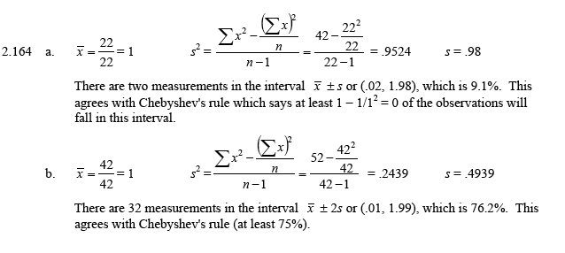
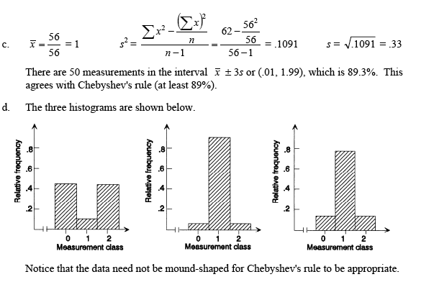

2.169 Rating of chess players. The United States Chess federation (USCF) establishes a
numerical rating for each competitive chess player. The USCF rating is a number
between 0 and 4,000 that changes over time, depending on the outcome of
tournament games. The higher the rating, the better (more successful) the player is.
The following table describes the rating distribution of 65,455 players who were
active USCF members in 2004:

USCF
-----------------------------------------------------------------------------------------------------------
Classification Rating Range Number of Players
-----------------------------------------------------------------------------------------------------------
Senior Master 2,800 to 2,809 1
Senior Master 2,700 to 2,799 13
Senior Master 2,600 to 2,699 66
Senior Master 2,500 to 2,599 87
Senior Master 2,400 to 2,499 133
Master 2,300 to 2,399 231
Master 2,200 to 2,299 691
Expert 2,100 to 2,199 783
Expert 2,000 to 2,099 1,516
Class A 1,900 to 1,999 1,907
Class A 1,800 to 1,899 2,682
Class B 1,700 to 1,799 3,026
Class B 1,600 to 1,699 3,437
Class C 1,500 to 1,599 3,582
Class C 1,400 to 1,499 3,386
Class D 1,300 to 1,399 3,139
Class D 1,200 to 1,299 3,153
Class E 1,100 to 1,199 2,973
Class E 1,000 to 1,099 3.021
Class F 900 to 999 3,338
Class F 800 to 899 3,520
Class G 700 to 799 3,829
Class G 600 to 699 3,946
Class H 500 to 599 3,783
Class H 400 to 499 3,544
Class I 300 to 399 3,142
Class I 200 to 299 2,547
Class J 0 to 199 3,979
-----------------------------------------------------------------------
Total Members 65,455
Average Rating 1,068
_ -------------------------------------------------------------------------------------------------------

a. Convert the information in the table into a graph that portrays the
distribution of USCF ratings.

b. What percentage of players have a USCF rating of 2,000 or higher?
(These players are “experts,” “masters,” or “senior master.”)

c. The mean USCF rating of the 65,455 players is 1,068. Give a practical
interpretation of this value.
Solution

b. 5.4%

c. average player rating is 1068

2.172 Achievement test scores. The distribution of scores on a nationally administered
college achievement test has a median of 250 and a mean of 540.

a. Explain why it is possible for the mean to exceed the median for this distribution
of measurements,

b. Suppose you are told that the 90th percentile is 660. What does this mean?

c. Suppose you are told that you scored at the 94th percentile. Interpret this
statement.

Solution

