Jordan Wente and Minzhe Li
nonmetric MDS:
Goal: to see which counties are most similar. I chose these key economic and demographic data as to identify key groupings based on statistical similarity. I utilized 6 variables: Median Income, 65 and over, percent population under 18, percent population over 65, % not proficient in English, percent population living in rural areas, and percent of elementary students eating free lunch.
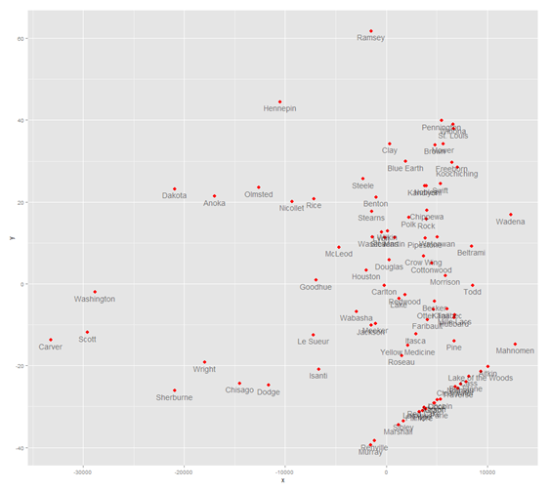

There are clearly 3 major curvilinear groupings. The first wave, to the far right, represents the urban and suburban counties. Carver, Scott, and Washington are one group, for example. In that this wave –that extends to Ramsey in the far right. The center section represents the “standard” Lutheran, industrial yet agrarian economies of southern and west central Minnesota.

Stress value = .0006929; my stress value indicated an excellent fit.
To standardize my median income values, I take the natural logarithm of median income and include this in my MDS analysis.
Ln(med_inc)
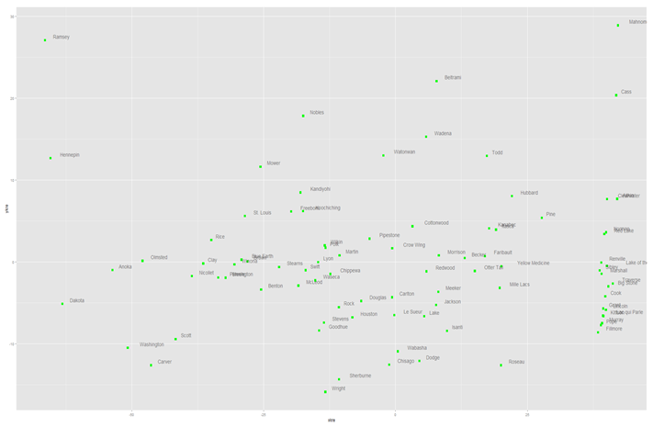
By taking the natural logarithm of median income, the counties are interestingly more evening dispersed on the 2D plane. Though, this is intuitive, as outliers like Wright or Carver counties are suppressed given the mathematical properties of the natural log function.
Cluster Analysis:
For our cluster analysis, we have selected the middle cluster of counties. Concerning health issues, we want to compare counties that are similar economically and demographically speaking. Simply, counties like Stevens do not face the same health concerns as counties like Olmsted or Hennepin.
The counties are:
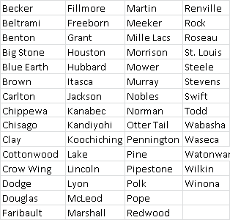
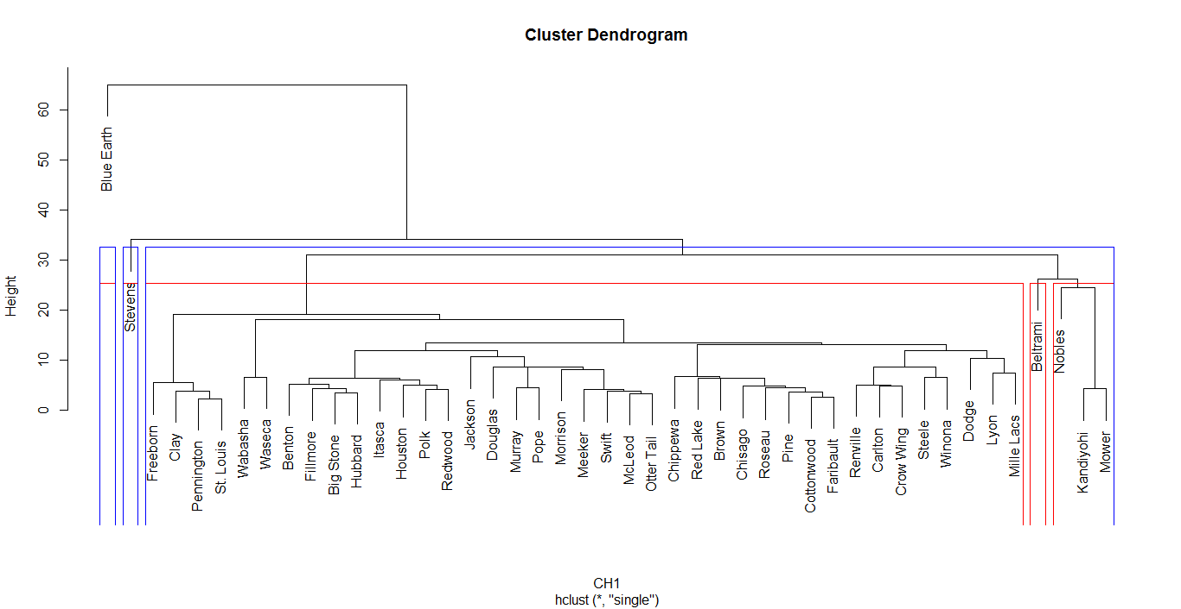
Normal Dendogram based on “single” method
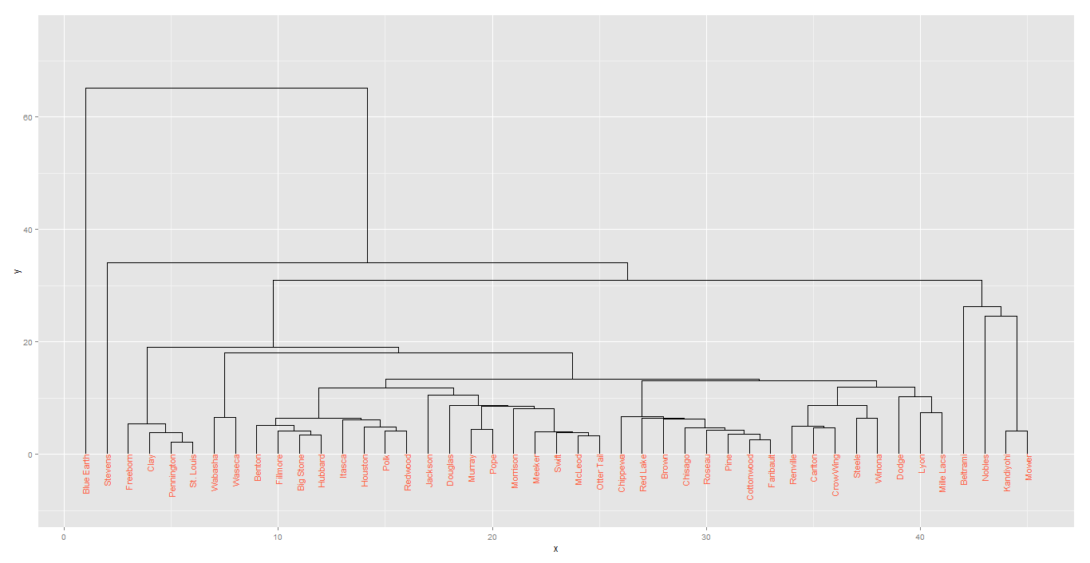
ggdendroplot
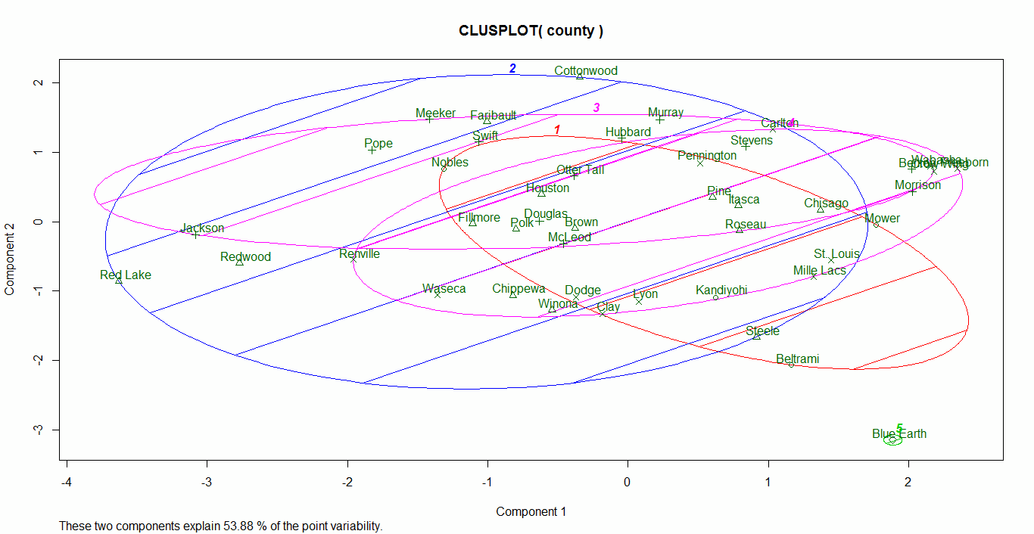

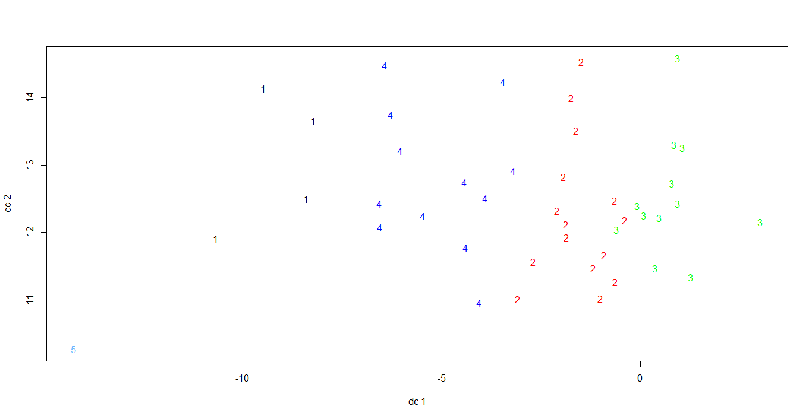
Results from clusplot based K-means Analysis
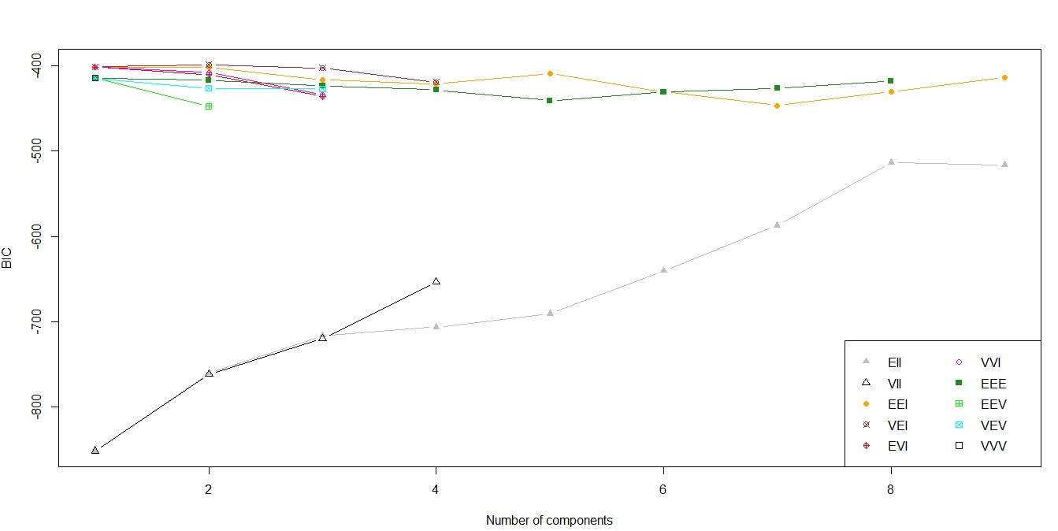
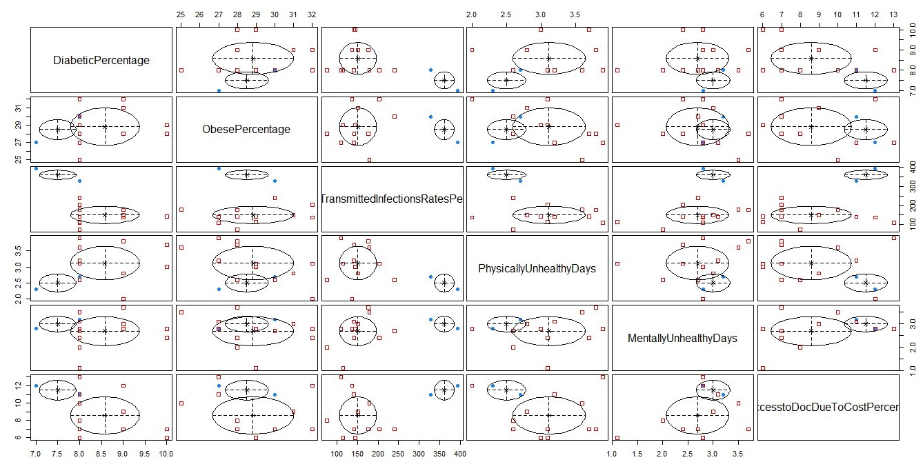
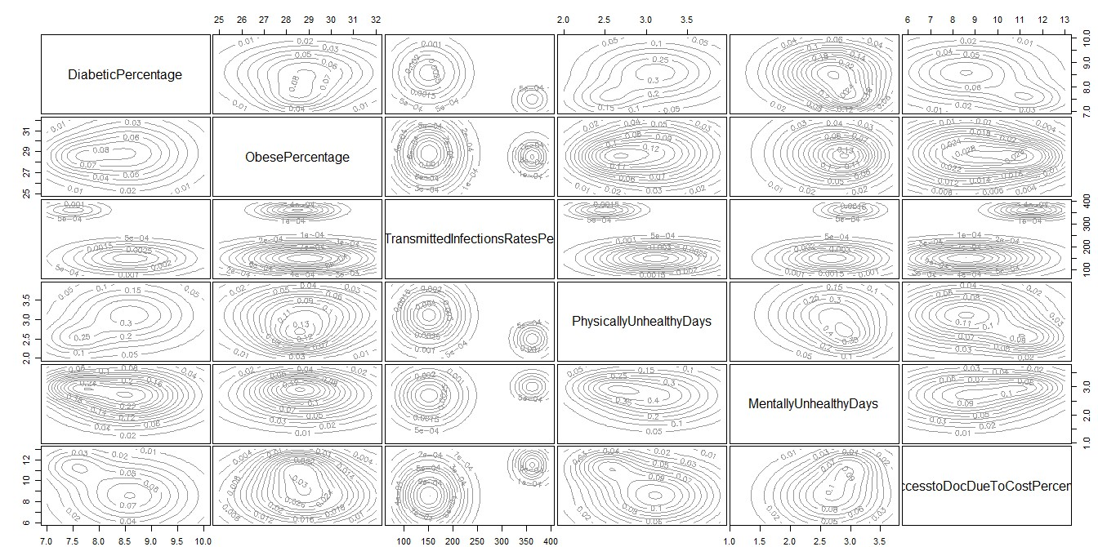
Model-Based Analysis of the first 15 counties in alphabetical orders

