Jier zhang/Nicholas skuby
Engine sungur
4/20
The cluster analysis project

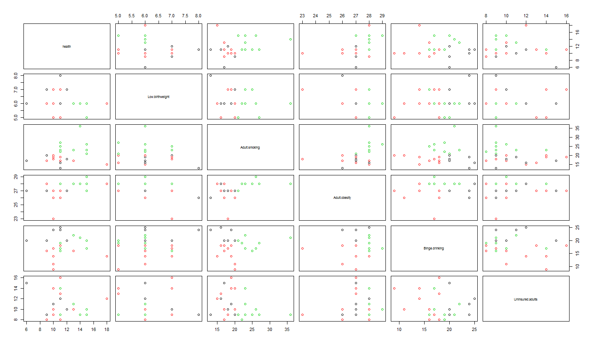
This is the kmeans graph we talked in the class, and our variables are the percentage of health, Low birthweight, Adult smoking, Adult obesity, Binge drinking, Uninsured adults.

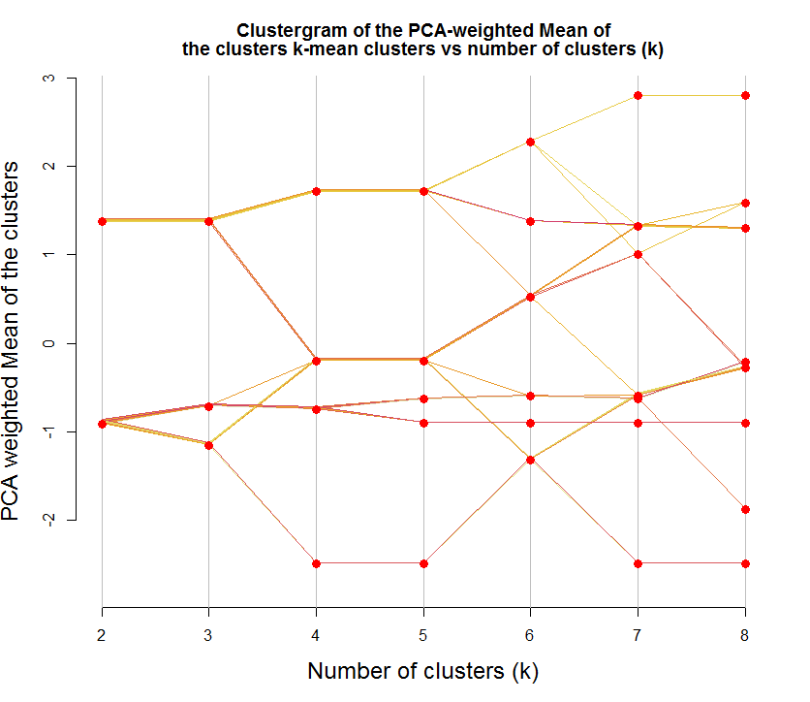
Here is the graph of Clustergram, which is using a R function and The code only works for kmeans, but it shows how such a plot can be produced, and could be later modified so to offer methods that will connect with different clustering algorithms.

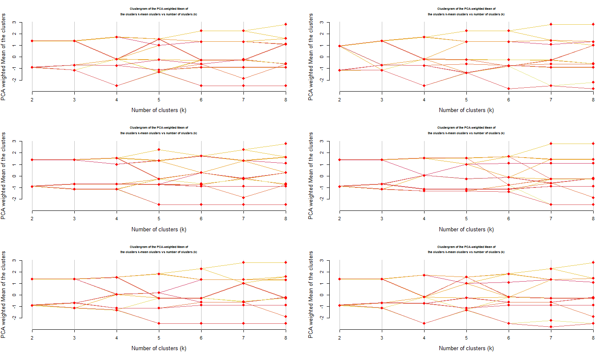
Here is the the algorithm running 6 more times (each run will have a different starting point for the clusters)

