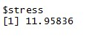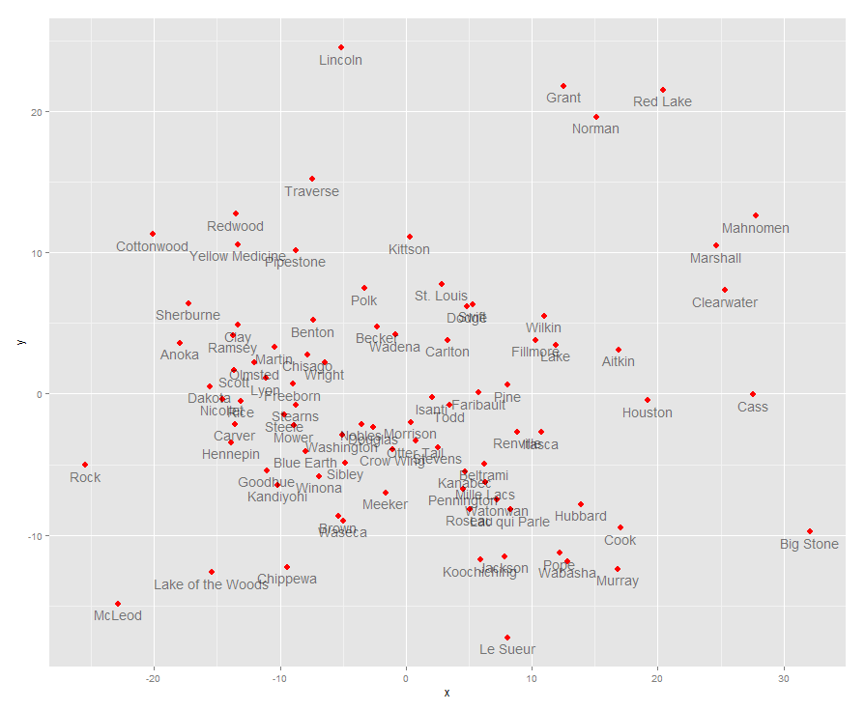

We produce this Non metric MDS based on the 2012 data: % single parent households, access to recreational, %limit access to healthy food, % fast food restaurant in order to see the relationship whether children with single parent will eat junk food or have no recreational life. The points spread out of the cluster( at the edge of graph) are counties with no recreational(maybe missing data) – “Grant, Red Lake, Norman, Cass, Big stone, Marshall”. In general, we discover the pattern that when the percentage of single parents rise, the children will have more chances to access to healthy food and the % of fast food restaurants will increase. As we all know, the owners of the fast food restaurant like to locate their restaurants around people who prefer eat outside. Single parent family may have less time to cook food, which means the higher the single parent family rate, the more the restaurants. As for the limited access to healthy food, we think that maybe most counties have good public facilities and social security. That is the main reason why with a huge number of single parents, counties still can provide enough nutrition for children. Morrison and Otter Tall are close, and when we check their data, they behave similarly through all the variables. Pennington and Kanabec are also very close to each other.
When we go through the x-axis from left to right, the rate of fast food restaurants will go down.
For the y-axis, % of recreational life will decrease when we look from bottom to top.
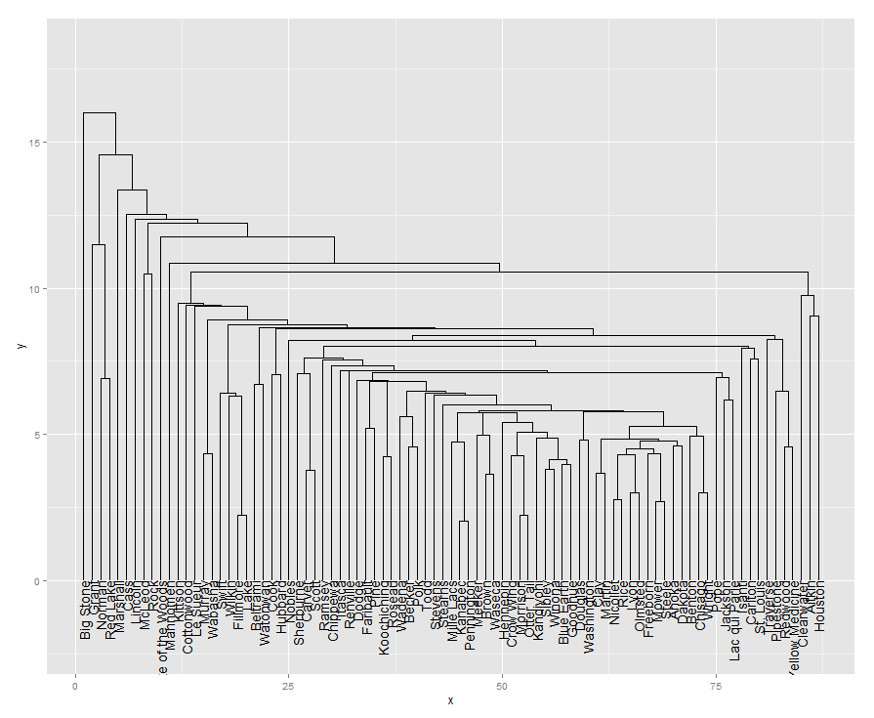
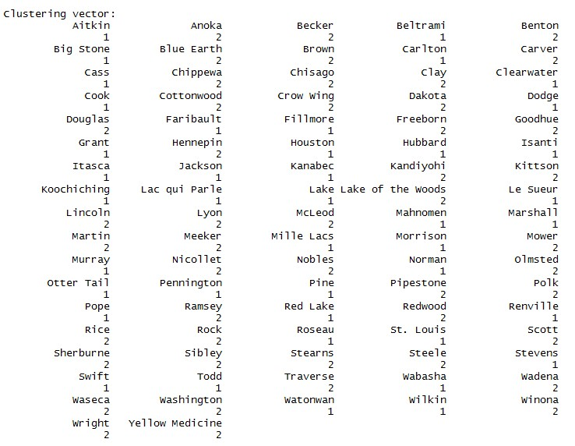
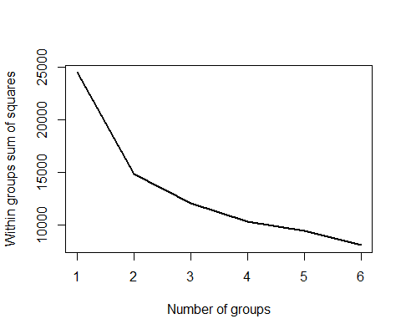
As for the second graph, we can easily discover that Big Stone, Grant, Norman, Red Lake, Marshall, etc are the last few counties join the group, which just as we concluded before. Pennington and Kanabec formed a cluster at the distance of 2; Morrison and Otter Tall merged to be cluster at the distance of 2.2.Corresponding to the first graph, these two pairs of groups are close enough.
By carrying out the k means, we find the elbow at 2. The counties which are at the edge of the first graph are assigned to the first group and all the other counties which in the cluster of the first graph are in the group 2.

