Bingjie wang
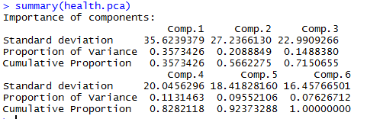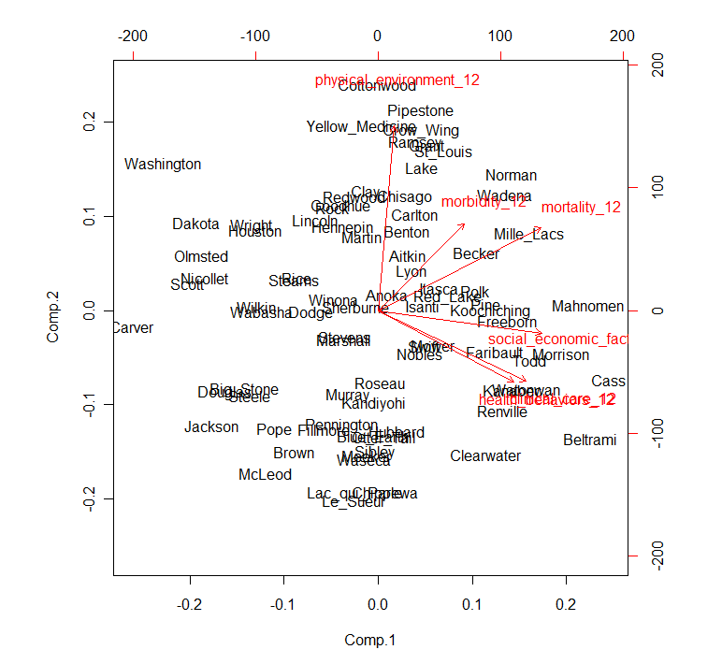

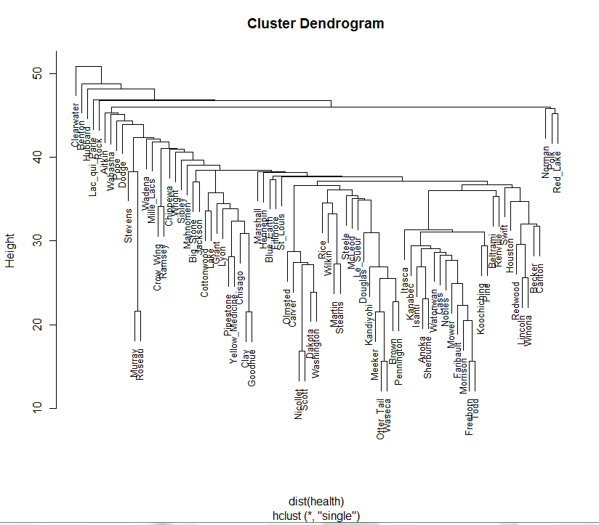
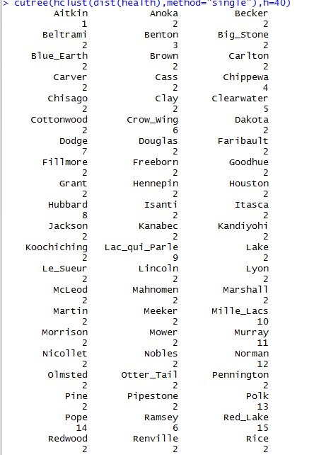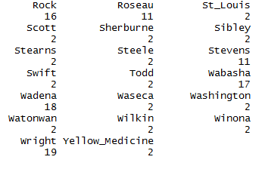
In the above pc plot, we find that fist PC can explain 35.7% of the total variance, and the second can explain the 20.8% of the total variance.
In another plot, we find that health behavior and the clinical care are close, so they are similar factor, and closer to each other. Physical environment has big effect on the comp.2. Social economic fact has effect on the comp.1.
In the cluster denfrogram, we can find some similar county in the total 83 variance.
Use the code below, we can find more information on different cluster on the special height.
cutree(hclust(dist(health),method="single"),h=k)

because the requirement is no more two page, the more information I find I will show them in the presentation.

